PHOTOSHOP: Jack O’ Lantern Transformation
For this activity, you are to “carve” a virtual pumpkin! You can make yours look however you wish, but the general settings should otherwise match mine (you just might have something other than the shapes of the face I use). There is a video out there as well, if that helps. First, download the pumpkin.jpg image off the class website and open it in Photoshop. Video help is online http://screencast-o-matic.com/channels/cXi0fcVu9
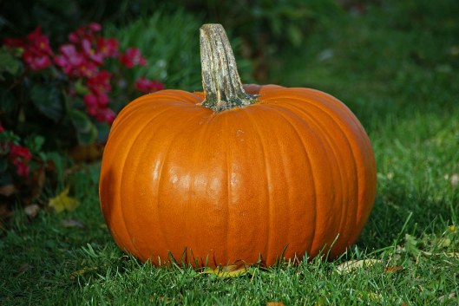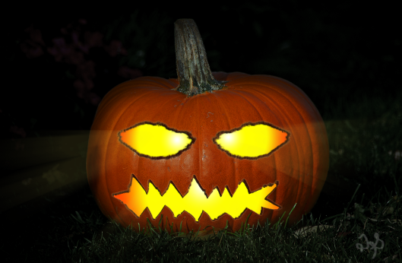
- Use the Quick Selection tool to select the pumpkin. Then, copy it to its own layer (r/c, Layer Via Copy). Name that layer pumpkin.
- On the Background layer, add a Levels Adjustment layer to darken the image and then add a Hue/Saturation Adjustment layer and pull the saturation down so the grass isn’t as green; you might also pull the lightness down as desired. This is all your call!!
- On the Pumpkin layer, add the Layer Style (fX) for Inner Shadow to make your pumpkin dark around the edges. Adjust the Distance, Choke, and Size so the inner shadow is large and diffused (I used 16, 24, and 155).
- Attach a Hue/Saturation layer to the pumpkin layer; be sure it clips to it so only the pumpkin is affected (easiest way it Layer> New Adjustment Layer> Hue/Sat and check the “use previous layer to create clipping mask” option). Make it more orange and a little darker (I set to -7, +5, and -13).
- Create a new layer (white paper button by trash can on Layers panel) and name it left eye (or whatever you are drawing).
- Using a black paintbrush, draw the outline of the left eye (or whatever). I strongly suggest you use an irregular brush. Something choppy looking. Or, after you draw it, go around it again with a choppy/grungy brush. It will look so much better later. Fill in your select with black (you can magic wand, select it, and Edit> Fill, black but you may have to repeat it to get all of it).
- Duplicate the left eye layer. Name the duplicate left eye inside. Move it below the other one and turn the eyeball off temporarily on the upper layer (left eye).
- On the left eye inside layer, apply these Layer Styles:
  - Bevel and Emboss: Set to Inner Bevel and Chisel Hard, probably around 104% depth and 5 px size (but up to you). Uncheck Use Global Light. Modify the angle to your desire (I used 153 degrees). Set the Highlight Mode to Normal and pick a light orange color from the pumpkin. Then, check Texture (as part of Bevel) and choose a texture scaled down to around 10%.
  - Color Overlay: Set to Normal and Orange. Roughly 50% Opacity.
  - Outer Glow: Pull Opacity back so it’s not too crazy.
- Now, turn on the left eye (the black one on top). Press Control+T and transform it so it fits into the eye hole. It should be smaller than the hole and repositioned to create depth.
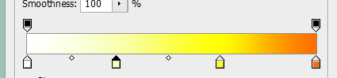
- On the left eye, apply these Layer Styles:
  - Bevel and Emboss (set to your liking)
  - Gradient Overlay: Set to the Orange/Yellow/Orange gradient but change the right side orange to white and add a second yellow one by the current one (spread them out evenly). Set to Radial gradient. Uncheck Align with Layer. Click Reverse so the Orange is at the left and white is at the inside. Set scale to around 40-50%. Now, take your mouse and pick up the gradient and move it so you can see part of the orange and white.
- Now, to make the right eyes, duplicate BOTH of the left eye layers.
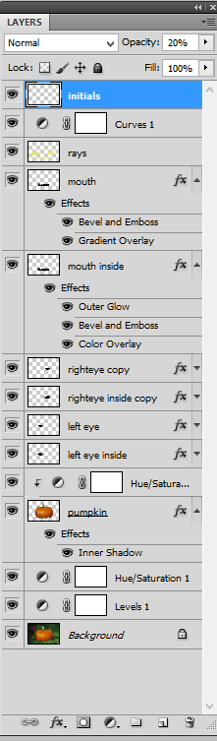
  - Drag them both to the “new layer” button and then rename each.
  - Click your right eye layer and press Control+T. Then, right-click and Flip Horizontal. Press the checkmark. Repeat for the right eye inside layer.
  - Press Control and select BOTH of those layers. Then take the Move tool and move it over into place.
  - On the top layer, adjust the Gradient Overlay to match the other eye. Basically, while editing the fX, just click and drag it over.
- Now, create another piece of your pumpkin face, like the mouth. Create a new layer and draw with a Brush like you did for the eyes, filling it in with black. Make the edges a little rough.
- Duplicate the mouth layer. Name the duplicate mouth inside.
- Right click the Left Eye layer; right click and Copy Layer Style. Then, click the Mouth layer; right click and Paste Layer Style. Repeat this for the inside layer. Then, position so the inside layer is below the other.
  - Control+T and size down the inside part a bit or you won’t be able to really see the bevel. Position it offset a little like we did the eye so it appears carved.
  - Then, in layer style, Modify Bevel as needed and adjust the Gradient position as needed.
- Create a new layer called rays. Draw some rays coming from the eyes and mouth using a soft yellow Brush.
- Now, blur that layer by adding a Radial Blur (Filter> Blur> Radial Blur) set to Zoom and turn it way up (90-100%). Then, pull the Opacity back on that layer to less than half so it looks more glowy.
- Finally, at the top of everything, do a Curves adjustment that makes it all spookier.
- Then, on a new layer, add your initials (draw them all spooky-like) in the corner. Pull the Opacity back on the layer. Yay!

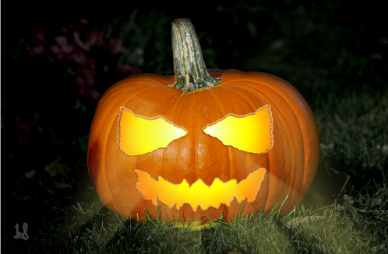

Idea adapted from video tutorial from here: http://photoshoptrainingchannel.com/halloween-jack-o-lantern-pumpkin/

