Photoshop HOPE Poster
- Before beginning, download and install this font-- http://www.dafont.com/primetime.font and take a serious picture of you contemplating life. Create a project folder called HOPE and save the image to that folder.
- Create a new document: Width 1000 pixels, Height 1515 pixels, Resolution 72 pixels/inch
Save as Hope Poster in PSD format.
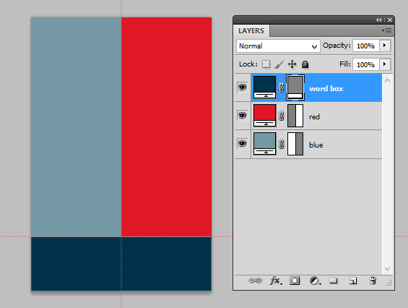
- Using the Rulers, drag a few guides to help line things up. Drag a guide over to 500 px (pull from the left ruler) to set the centerpoint. Drag one from the top ruler down to around 1210 px for the top of the “Hope” box. You may need to right click your ruler and set it to pixels (if you don’t see the ruler, try the View menu).
- Draw a blue rectangle with the fill color #7498A4 (the light blue color). That should go on the left. Draw a red rectangle with the fill color #E01825 (the red color). That goes on the right. Use your guides to line them up.
- Finally, draw the lower word box using a dark blue rectangle and color #00324D. Remember to line the top of the box up with your guide. Name layers!
- Open your photograph of yourself. Select your person (remove background) and drag over heads and maybe a little shoulder. No more. (Suggestion: When using Refine Edge, output to New Layer with Layer Mask so you can touch it up after you drag it over). Then, transform and position on the layer below the word box layer.
- We are going to do lots of things to the person layer! Get ready!
  - First, adjust the levels so the photo has good contrast (Image> Adjustment> Levels; click Auto and then pull up the black levels if needed for contrast)
  - Apply the Cutout Filter (you will do this destructively to the layer)
    - Filter> Artistic> Cutout
    - Number of levels=5, Edge simplicity=5, Edge fidelity=1 (if these settings make your features disappear, you might need to back up and try better Levels first)
  - Add an Adjustment Layer
    - Click the Adjust layer icon and choose Channel Mixer (on Layers panel);
      - Check Monochrome to make the image black and white
      - Click the button at the bottom to Clip to the layer
    - Click Back on Adjustment panel and choose Posterize
      - Change levels from 4 to 5 (this will help us create a 5 color gradient in a sec)
      - Click the button at the bottom to clip to the layer
    - Click Back on Adjustments panel (click the back button), select Gradient Map. Click the gradient to bring up the Gradient Editor. Set the stops as follows:
      - left is dark blue-- color #00324D
      - create second marker at location 25%-- red color #E01825
      - create marker in the middle at location 50%-- light blue color #7498A4
      - add another marker at location 75%-- yellow color #FDE5A9
      - change/set final marker to match the fourth one (yellow color above, not white)
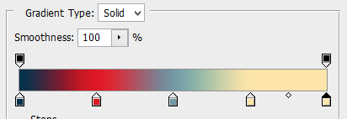
      - Press OK and click the clipping mask button so it only applies to the person layer.
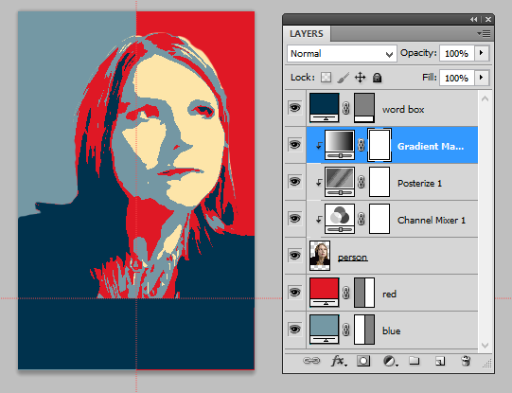
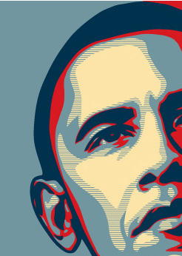
Add Cool Lines:
The examples online have some “line” built in to the image. To add something like that, try this method:
- Hide all layers (eyeballs) so the only visible layer is your person, and click to be sure it is active
- Get magic wand tool with Tolerance 10
- Click on the second lightest tone (what would be the light blue; temporarily toggle on the gradient map layer if you need to see where to click, but turn it back off)
- Create a New Layer above the person and press the Layer Mask button 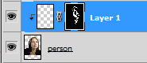
- Paint in gray on that new layer (on the layer, not the mask); to get gray, set brush color to black and then set the brightness (B) to 50% on the color picker box. It should look like this after you paint 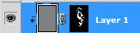
- Turn all layers and adjustment layers back on; move this new layer to the top of the stack of adjustment layers. Name it lines.
- To Lines Layer, apply a filter to create lines:
  - Filter> Sketch> Halftone pattern
  - Size is 1, Contrast is 50, Pattern type must be line
  - Touch up the mask so you still have some light blue areas:
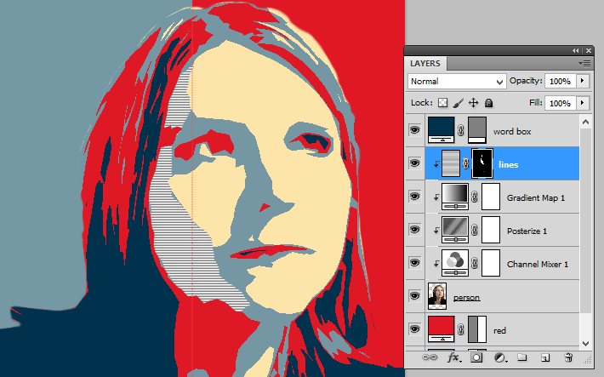

Final Touches:
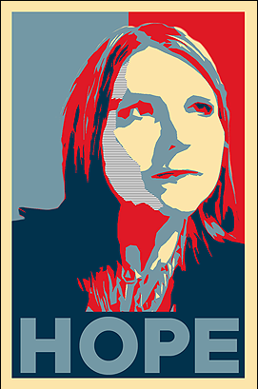
- Add your words; use Primetime font and size 275pt with the light blue color-- #71969F (pick an appropriate four-letter word to represent your outlook—hope, nope, cool, etc.).
- Create a Rectangle on the top of everything. Set the fill to 0% in Layers panel (not the Opacity, the Fill). Add a fX for Stroke. Set it to inside, 50px and that yellow color-- #FDE5A9. Be sure it covers to the edge. Transform as needed to ensure!
- Save the design! Then, save a copy for your portfolio folder (Save for Web).

Video Tutorial Adapted from Blue Lightning TV https://www.youtube.com/watch?v=j2_YwylZaDE
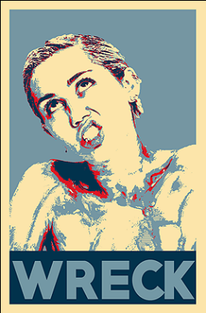
My YouTube Tutorial:
https://goo.gl/sPG1Xk

If time permits, try creating a parody
with a celebrity image!
Here’s mine!

