Copycat Magazine Cover—Prep Assignment—Identification
Group Activity
Locate/Identify these features….
--not all will be used
- Image 1, 2, 3
- Barcode
- Text in a shape
- Background removed from photo
- Rotated text
- Script font
- Sans serif font
- Fx-Drop shadow
- Fx-Gradient overlay
- Fx-Outer glow
- Fx-Stroke
- Fx-Bevel
- Other-Pen drawn shape
- Other-Custom shape
- Other-Text scale modification (horizontal/vertical)
- Other-Clipping mask (picture inside non-rectangle shape)
- Other-Feathered edge (soft brush on mask)
- Other-Transparency

***When you select the cover you wish to copycat, you must label it with any items listed as well.
Fonts—
Serif: Has “serifs” hanging from it Example—Times New Roman Adobe Caslon Baskerville
Sans Serif: Plain, straight fonts with no serifs Example—Agency Arial Tw Cen Mt
Script: Handwritten looking, cursive fonts Example—Edwardian Script Brush Script Lucida
Copycat Magazine Preparation
Label on your example the following things:
- Picture 1
- Picture 2
- Picture 3 (3 required; label up to 5, after that you can stop)
- Text in Shape
- BG removed from photo (on one of your images, the background has to be separated from the subject; this might be a head in front of letters or a picture that has no background floating around someplace)
- fX 1-- ______________ (stroke, drop shadow, glow, bevel, gradient fill, etc.)
- fX 2-- ______________ (only two different ones are required)
- fx 3--_______________ (if you have three or more, just list 3; these are three different ones)
- Other-- _____________ (other stuff—letter tracking, transparency, blur filter, clipping mask, shapes, brush stamps, adjustments layers, etc.)
- Other-- _____________
- Other-- _____________ (2 required; label up to three)
- Barcode (if it has one; if not, you will add it so identify where)
Other—Rasterized Text with Mask
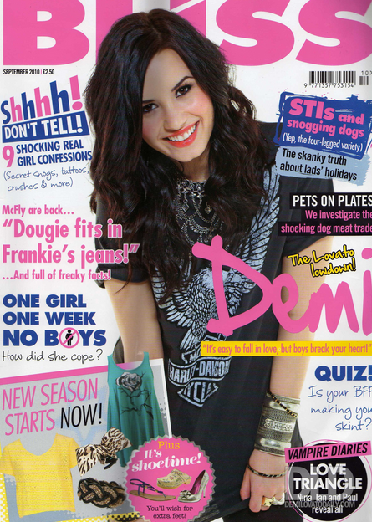
Other- Pen Tool
Barcode
Other- Letter Kerning (they touch)
Fx3-GradientStroke
Other—
Custom Brush Stamp (paint)

Other- Warp
Fx2-Drop Shadow
Fx1-Stroke
Background removed from photo
Text in shape
Pic 3
Pic 2
Pic 1

